Data Communication:
The exchange of data between two devices through a transmission medium is called Data Communication. The data is exchanged in the form of 0's and 1's. The transmission medium used is wire cable. For data communication to occur, the communication device must be a part of a communication system. Data Communication has two types - Local and Remote which are discussed below:
Data Communication: Local
Local communication takes place when the communicating devices are in the same geographical area, same building, or face-to-face etc.
Data Communication: Remote
Remote communication takes place over a distance i.e. the devices are farther. The effectiveness of a data communication can be measured through the following features :
- Delivery: Delivery should be done to the correct destination.
- Timeliness: Delivery should be on time.
- Accuracy: Data delivered should be accurate.

Components of Data Communication
- Message: It is the information to be delivered.
- Sender: Sender is the person who is sending the message.
- Receiver: Receiver is the person to whom the message is being sent to.
- Medium: It is the medium through which the message is sent. For example: A Modem.
- Protocol: These are some set of rules which govern data communication.

Line Configuration in Computer Networks
A Network is nothing but a connection made through connection links between two or more devices. Devices can be a computer, printer or any other device that is capable to send and receive data. There are two ways to connect the devices :
- Point-to-Point connection
- Multipoint connection

Point-To-Point Connection
It is a protocol which is used as a communication link between two devices. It is simple to establish. The most common example for Point-to-Point connection (PPP) is a computer connected by telephone line. We can connect the two devices by means of a pair of wires or using a microwave or satellite link.
Example: Point-to-Point connection between remote control and Television for changing the channels.
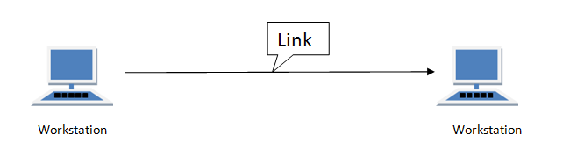

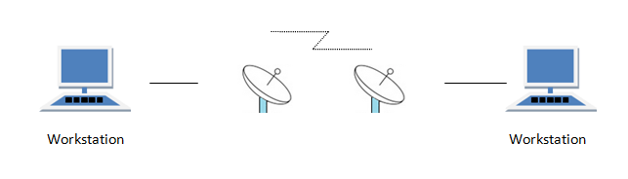

MultiPoint Connection
It is also called Multidrop configuration. In this connection two or more devices share a single link.
There are two kinds of Multipoint Connections :
- If the links are used simultaneously between many devices, then it is spatially shared line configuration.
- If user takes turns while using the link, then it is time shared (temporal) line configuration.
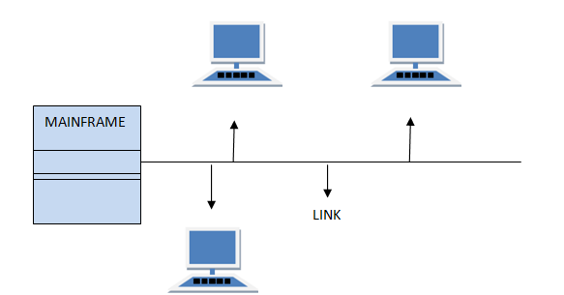

Overview of a Network
The connection of two or more computer with cable or without cable within a limited room or to the entire world is called computer network.
Generally a communication network is an arrangement where a sender transmits a message to a receiver over a channel consisting of some type of medium. That is, in computer networks, computers are interconnected by means of transmission medium (using different cable). If two computers are able to exchange information, they are said to be interconnected. The connection between computers can be wired and wireless.
Advantages/Applications of networking:
- Resource sharing: one of the advantages of computer networking is resource sharing. By Resource sharing, we mean that the same resource can be used by more than one user. The resource can be thing like peripheral devices (e.g. printers) and the other information stored in the computers.
- Simultaneous access: By the use of networking, different users can access the same information or data files at the same time.
- Access to remote information: with the use of networking, we can access information stored on computer that lies at far distance. For e.g. we can download useful documents from remote server to our computer.
- Person to person communication: Another use of computer network is in the field of person to person communication. With computer network we can sent email and do chat with our friends.
Communication Media: computers and other communication devices use signals to represent data. These signals are transmitted from one device to another in the form of electromagnetic energy, which is propagated through media called transmission or communication media. These include twisted-pair wire, coaxial cable, fiber optics, microwave systems etc.
For the purpose of communication, transmission media can be divided into two broad categories.
- Guided media
- Unguided media (wireless)
Guided media are those that provide a channel from one device to another. Eg. Twisted-pair cable, coaxial cable, and fiber-optic cable. A signal traveling along any of these media is directed and contained by the physical limits of the medium. Unguided media transport electromagnetic waves without using a physical conductor. This type of communication is often referred to as wireless communication. Signals are normally broadcast through air and thus are available to anyone who has a device capable of receiving them.

Twisted-pair cable: A twisted pair consists of two insulated copper wires, typically about 1mm thick. The wires are twisted together.. The purpose of twisting the wires is to reduce electrical interference from similar pairs close by. The number of twists per unit of length determines the quality of the cable. i.e., more twists mean better quality.
Twisted pairs can run several kilometers without amplification, but for longer distances, repeaters are needed. Twisted pairs can be used for either analog or digital transmission. The bandwidth depends on the thickness of the wire and the distance traveled. There are two categories of twisted pair cable:
- Unshielded twisted pair (UTP)
IT is one of the most common type of telecommunication medium in use today. Its frequency range is suitable for transmitting both data and voice. twisted pair consists otf two conductors each with its own colored plastic insulation. The twisting is done in order to avoid the inference of noise. Twisting does not eliminate the noise completely ,it reduces the effect of noise on the cable..UTP cost cheap, easy in use, flexible in use, easy to install. Most LAN(local area network uses this types of cable) example:RJ-45 connector. Telephone lines.
- Shielded twisted pair (STP)-STP cable has a metal foil or braid-mesh covering that encases each pair of insulated conductors. Although metal casing improves the quality of cable by preventing noise or cross talk which is more expensive than UTP.
Coaxial Cable: A coaxial cable consists of a stiff copper wire as the core, surrounded by an insulating material. The insulator is encased by a cylindrical conductor. The outer conductor is covered in a protective plastic covering. It has better shielding than twisted pair, so it can span longer distances at higher speeds. coaxial cable carries signals of higher frequency ranges than twisted-pair cable. Two kinds of coaxial cable are widely used. One kind, 50-ohm cable, is commonly used for digital transmission, called baseband coaxial cable. The other kind, 75-ohm cable, is commonly used for analog transmission, called broadband coaxial cable. The construction and shielding of the coaxial cable give it a good combination of high bandwidth and excellent noise immunity. Applications of coaxial cable are cable TV, MAN etc.

Protective plastic covering
Outer conductor
Insulating material
Copper wire

Fiber-Optic Cable: A fiber-optic cable is made of glass or plastic and transmits signals in the form of light. Because light travels much faster than electricity, optical fibers can transmit data at much higher speed than copper wires or coaxial cables and also with not significant loss of intensity over very long distances.Plastic fibers are least efficient ,but tend to be cheaper and more rugged, Optical fibers use reflection to guide light through a channel. A glass or a plastic core is surrounded by a cladding of less dense glass or plastic so that a beam of light moving through the core is reflected off the cladding instead of being refracted into it.
Advantages of Optical Fiber:
- Larger bandwidth
- Less signal attenuation
- Immunity to electromagnetic interferences
- Light weight etc.
Disadvantages of Fiber Optics:
- Installation/maintenance needs expertise that may not be available everywhere.
- High cost.
Microwave Systems: Electromagnetic waves having frequencies between 1 and 300 GHZ are called microwaves. Microwaves are unidirectional. When an antenna transmits microwave waves, they can be narrowly focused. This means that the sending and receiving antennas need to be aligned. A pair of antennas can be aligned without interfering with another pair of aligned antennas.

Microwave propagation is line-of-sight. Since the towers with the mounted antennas need to be in direct sight of each other, towers that are far apart need to very tall. Obstacles do not allow two short towers to communicate using microwaves. Repeaters are often needed for long distance communication. Microwaves are used for unicast communication such as cellular telephones and wireless LANs.
Satellite Communication: A communication satellite is basically a microwave relay station placed in outer space. These satellites are positioned 36000 kms above the equator with an orbit speed that exactly matches the earth’s rotation speed. Since a satellite is positioned in a geosynchronous orbit, it is stationary relative to earth and always stays over the same point on the ground. In satellite communication, microwave signal is transmitted from a transmitter on earth to the satellite positioned in space. By the time this signal reaches the satellite it becomes weak. The satellite amplifies the weak signal and transmits it back to the earth. This signal is receives at a receiving station on the earth. The retransmission frequency is different from transmission frequency in order to avoid the interference of the powerful retransmission signal with the weak incoming signal.
The main problem with microwave communication is that the mountains and other obstacles often block the line-of-sight. So, several repeaters are required for long distance transmission which increases the cost. This problem is overcome by using satellites. In satellite communication, transmission and reception costs are independent of the distance between two points. Another advantage of satellite communication is that satellites are visible from any point of a very large area. So, transmission and reception can be between any two randomly chosen places in that area. However, a major drawback of satellite communications has been the high cost of placing the satellite into its orbit. Moreover, a signal sent to a satellite is broadcast to all receivers within the satellite’s range. Hence necessary security measures are to be taken to prevent unauthorized tampering of data.

Network Topologies: The term topology is borrowed from geometry to describe the form of something. Network topology refers to the way in which the nodes (computers or other devices) of a network are linked together. That is, it is the physical layout of the cables that connect the nodes of the network. Three commonly used topologies are:

- Star topology
- Ring topology
- Bus topology
- Mesh Topology

1.Star Topology: In star configuration of computer networks, there is a host computer which is attached to local computers through multiple communication lines. The local computers are not linked directly to each other and can communicate only via the host computer. The routing function is performed by the host computer which centrally controls communication between any two local computers by establishing a logical path between them.
Advantages:
- Easy to install, reconfigure and troubleshoot
- Transmission delays between two nodes do not increase by adding new nodes to the network.
- If any of the local computers fail, the remaining portions of the network is unaffected.
Disadvantages:
- It requires more cable than bus topology
- If the host computer fails, the entire network fails.

HUB
Local computers
Fig. star Topology
2.Ring Topology: In the ring network, the nodes of the network are connected in a circular chain in which each node is connected to the next. The final node in the chain connects to the first to complete the ring. A node receives data from one of its two adjacent nodes. The only decision a node has to take is whether the data is for its use or not. If it is addressed to it, it utilizes it. Otherwise, it passes it on to the next node.
Advantages:
- It works well where there is no central computer system. It is truly distributed data processing system.
- It is more reliable than a star network because communication is not dependent on a single host computer.
- Short cable length.
Disadvantages:
- Adding new nodes in the network increase the communication delays.
- If at any point the cable breaks then entire network stops functioning.
- It needs more complicated software to control hence not so popular than other topologies.
C1
C2
C4
C3
Fig-Ring Topology

3.Bus Topology: This type of topology consists of a single length of the transmission medium onto which the various nodes are attached. In this case, the transmission from any station travels the length of the bus, in both directions, and can be received by all other stations. The bus has terminators at either end which absorb the signal, removing it from the bus. Data is transmitted in small blocks called packets. Each packet has some data bits, plus a header containing its destination address.
Advantages:
- Easy to extend. New computers can be added to the network easily.
- Short cable length and simple wiring layout as there is single common data path connecting all nodes.
- Highly reliable because the failure of a computer in the network does not effect the functioning of the network.
Disadvantages:
- Since there is only one communication channel to service all the devices on the network, the entire network is lost in the event of failure of the communication channel
- High risk of data collision.

4.Mesh Topology: A mesh topology is a network is a network where computers are linked to each other through intermediate nodes with redundant path. In mesh topology all the computers are interconnected each other. The internet is an example of large mesh topology. Mesh topologies involve the concept of routes. Unlike each of the previous topologies, messages sent on a mesh network can take any of several possible paths from source to destination. (Recall that even in a ring, although two cable paths exist, messages can only travel in one direction.) Some WANs, most notably the Internet, employ mesh routing. A mesh network in which every device connects to every other is called a full mesh. As shown in the illustration below, partial mesh networks also exist in which some devices connect only indirectly to others.
Fig. Bus Topology
Advantages:
  - -The major advantage of the mesh is fault tolerance
  - -communication channel capacity is guaranteed.
Disadvantages:
  - -Difficult to installation and reconfiguration.
  - -Cost of maintaining redundant links.

C1
C3
C5
C4
C2

Fig: Mesh Topology

5.TREE Topology
It has a root node and all other nodes are connected to it forming a hierarchy. It is also called hierarchical topology. It should at least have three levels to the hierarchy.
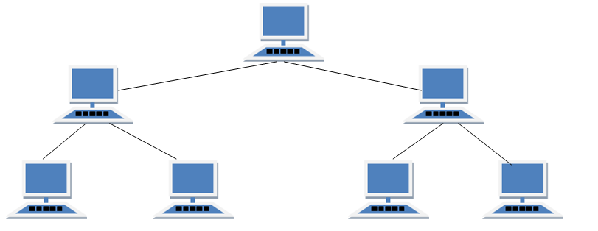
Features of Tree Topology
- Ideal if workstations are located in groups.
- Used in Wide Area Network.
Advantages of Tree Topology
- Extension of bus and star topologies.
- Expansion of nodes is possible and easy.
- Easily managed and maintained.
- Error detection is easily done.
Disadvantages of Tree Topology
- Heavily cabled.
- Costly.
- If more nodes are added maintenance is difficult.
- Central hub fails, network fails.

- HYBRID Topology
It is two different types of topologies which is a mixture of two or more topologies. For example if in an office in one department ring topology is used and in another star topology is used, connecting these topologies will result in Hybrid Topology (ring topology and star topology).
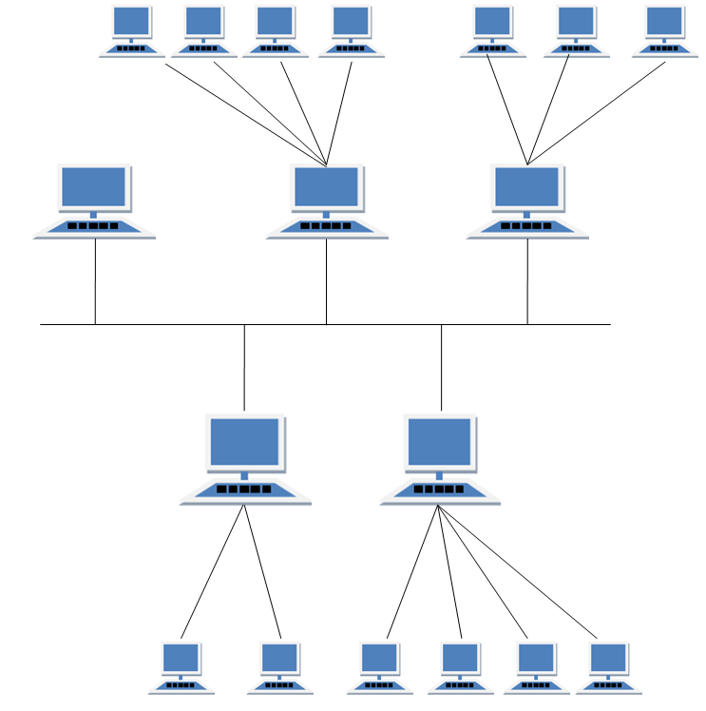
Features of Hybrid Topology
- It is a combination of two or topologies
- Inherits the advantages and disadvantages of the topologies included
Advantages of Hybrid Topology
- Reliable as Error detecting and trouble shooting is easy.
- Effective.
- Scalable as size can be increased easily.
- Flexible.
Disadvantages of Hybrid Topology
- Complex in design.
- Costly.

Types of Networks:
Basically there are three types of networks based on size.
- Local Area Network (LAN)
- Metropolitan Area Network (MAN)
- Wide Area Network (WAN)

1.Local Area Network (LAN): A LAN is a communication system capable of interconnecting a large number of computers, terminals, and other peripheral device within a limited geographical area, typically around 1 KM. LANs normally operate within a compact area such as an office building or a campus and is owned by that organization. The configuration of a LAN can be Star or a Ring or Bus. In LAN, transmission channels generally use coaxial or fiber optic cable. Thus transmission speed is very high.LAN are created from 1m to 1km.
The two main purposes of LAN are:
To link computers within an organization or campus so that they may share expensive peripheral devices, for example printers.
To allow these computers to communicate with each other.
Examples of LANs are Ethernet.
.
Fig: A LAN

2. Metropolitan Area Network (MAN): A MAN is a network that is larger than LAN. It is called metropolitan since it normally covers the area of a city (about 100 kms). Such- network may use cables as transmission media or wireless links.The MAN consists of different hardware and software configuration.

Bhaktpur
kathmandu
Lalitpur
Fig: A MAN

3.Wide Area Network (WAN): A WAN includes all networks larger than a MAN.we can say WAN is simply LAN of LAN.WAN is a communication system which interconnects different computer installations, user terminal and also enables LANs to communicate with each other. WAN connects different types of network together.WAN are characterized by the slowest data communication rates and largest distance.This type of communication network may be developed to operate nationwide or worldwide. In a WAN, the transmission medium used are normally public systems such as telephone lines, microwave and satellite links. Examples of WAN are ARPANET, INDONET and INTERNET.
Two components used in WAN for communication are:
Transmission lines: Transmission lines move data between host computers.
Switching elements: They are specialized computers used to connect two or more transmission lines. When data arrive on an incoming line, the switching element selects the forward path for the data. Example - router.

Differences between LAN and WAN:
A LAN is restricted to a limited geographical coverage of a few kilometers, but a WAN spans greater distance and may operate nationwide or even worldwide.
Data transmission rate is much higher in LAN than in WAN.
Cost to transmit data in LAN is negligible in comparison to WAN since in WAN public systems such as telephone lines, microwave and satellites are used as transmission media.
Fewer data transmission errors occur in case of a LAN as compared to a WAN. Because, in LAN, distance covered by the data is negligible as compared to a WAN

Reference Model
Reference Model offers a means of standardization which is acceptable worldwide. Since people using the computer network are located over a wide physical range and their network devices might have heterogeneous architecture. In order to provide communication among heterogeneous devices, we need a standardized model i.e. a reference model, which would provide us way how these devices can communicate regardless their architecture.
We have two reference models such as OSI model and TCP/IP reference model, however, the OSI model is a hypothetical one but the TCP/IP is absolutely practical model.

OSI Model
OSI is acronym of Open System Interface. This model is developed by the International organization of Standardization (ISO) and therefore also referred as ISO-OSI Model.
The OSI model consists of seven layers as shown in the following diagram. Each layer has a specific function, however each layer provide services to the layer above.
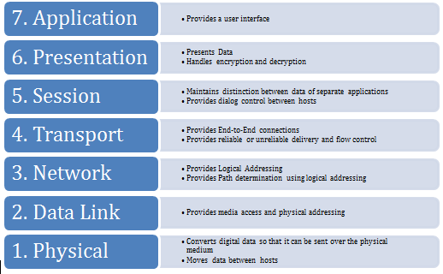

Physical Layer
The Physical layer is responsible for the following activities:
- Activating, maintaining and deactivating the physical connection.
- Defining voltages and data rates needed for transmission.
- Converting digital bits into electrical signal.
- Deciding whether the connection is simplex, half duplex or full duplex.

Data Link Layer
The data link layer performs the following functions:
- Performs synchronization and error control for the information which is to be transmitted over the physical link.
- Enables error detection, and adds error detection bits to the data which are to be transmitted.

Network Layer
Following are the functions of Network Layer:
- To route the signals through various channels to the other end.
- To act as the network controller by deciding which route data should take.
- To divide the outgoing messages into packets and to assemble incoming packets into messages for higher levels.

Transport Layer
The Transport layer performs the following functions:
- It decides if the data transmission should take place on parallel paths or single path.
- It performs multiplexing, splitting on the data.
- It breaks the data groups into smaller units so that they are handled more efficiently by the network layer.
The Transport Layer guarantees transmission of data from one end to other end.

Session Layer
The Session layer performs the following functions:
- Manages the messages and synchronizes conversations between two different applications.
- It controls logging on and off, user identification, billing and session management.

Presentation Layer
The Presentation layer performs the following functions:
This layer makes it sure that the information is delivered in such a form that the receiving system will understand and use it

Application Layer
The Application layer performs the following functions:
- It provides different services such as manipulation of information in several ways, retransferring the files of information, distributing the results etc.
- The functions such as LOGIN or password checking are also performed by the application layer.

Network Architecture
The term architecture can refer to either hardware or software, or a combination of both. The architecture of a system always defines its broad outlines, and may define precise mechanisms as well. Network architectures can be broadly classified as
- Peer-to-peer Architecture
- Client/Server Architecture
Peer-to-peer Architecture: In this type of network, all the computers in network are both clients and servers. That is, all computers both request and provide network services. Here, all computers have equal relationship to all other computers. This type of computer system is also known as distributed network system. This type of network is generally used in the colleges, where networking is needed only to facilitate the sharing of the general information and peripheral devices like printer. The information to be shared is kept in shared mode. The user , which has the authority to use the file, can access it.
Peer-to-peer networks are generally simpler and less expensive. Their performance degrades in the case of heavy loads. There is no central repository for files and applications. It does not provide the security available on a client/server network.
Client/Server Architecture: In client server network, all computers have distinctly defined roles. Each computer on the network is either a client or a server. Servers are usually powerful computers, which respond to the request sent by the client machine. Clients rely on server and send request to it for resources like files, information, devices and even processing power.
If a user needs information from a server, it sends a request to a server. The server contains the database with the record of the items in the server. The server processes the search and when the data is found, it sends it to the user who had requested it.
The most example of client/server computing involves a database that can be addressed by many different computers on the network. The database is stored on the network server. Client/server architecture is valuable to large, modern organizations because it distributes processing and storage workloads among resources efficiently.

Network Protocols:
Network protocol is a set of rules that governs data transmission and reception. It represents an agreement between the communicating devices. The protocol defines:
- Types of error checking to be used.
- Data compression method, if any.
- How a sending device will indicate that it has finished sending a message.
- How a receiving device will indicate that it has received a message.
Examples of network protocols are Ethernet, Token Ring, TCP/IP, HTTP, FTP etc.
SNMP (Simple Network Management Protocol) — Used to control the connected networking devices.
TFTP (Trivial File Transfer Protocol) — Used to transfer the files rapidly.
DNS (Domain Naming System) — Used to translate the name with IP address and vice versa.
DHCP (Dynamic Host Configuration Protocol) — Used to assign IP address and DNS information automatically to hosts.
Telnet— used to connect remote devices.
HTTP (Hypertext Transfer Protocol) — Used to browse web pages.
FTP (File Transfer Protocol) — Used to reliably sends/retrieves files.
SMTP (Simple Mail Transfer Protocol) — Used to sends email.
POP3 (Post Office Protocol v.3) — Used to retrieves email.
Computer Network Devices:
Hardware devices that are used to connect computers, printers, fax machines and other electronic devices to a network are called network devices. These devices transfer data in a fast, secure and correct way over same or different networks. Network devices may be inter-network or intra-network. Some devices are installed on the device, like NIC card or RJ45 connector, whereas some are part of the network, like router, switch, etc. Let us explore some of these devices in greater detail.
Hub
Hub is one of the basic icons of networking devices which works at physical layer and hence connect networking devices physically together. Hubs are fundamentally used in networks that use twisted pair cabling to connect devices. They are designed to transmit the packets to the other appended devices without altering any of the transmitted packets received. They act as pathways to direct electrical signals to travel along. They transmit the information regardless of the fact if data packet is destined for the device connected or not.
Hub falls in two categories:
Active Hub: They are smarter than the passive hubs. They not only provide the path for the data signals infact they regenerate, concentrate and strengthen the signals before sending them to their destinations. Active hubs are also termed as ‘repeaters’.
Passive Hub: They are more like point contact for the wires to built in the physical network. They have nothing to do with modifying the signals.
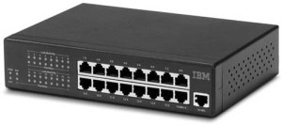
Switches
Switches are the linkage points of an Ethernet network. Just as in hub, devices in switches are connected to them through twisted pair cabling. switch is a network device that connects other devices to Ethernet networks through twisted pair cables. It uses packet switching technique to receive, store and forward data packets on the network. The switch maintains a list of network addresses of all the devices connected to it.On receiving a packet, it checks the destination address and transmits the packet to the correct port. Before forwarding, the packets are checked for collision and other network errors. The data is transmitted in full duplex mode. Data transmission speed in switches can be double that of other network devices like hubs used for networking. This is because switch shares its maximum speed with all the devices connected to it. This helps in maintaining network speed even during high traffic. In fact, higher data speeds are achieved on networks through use of multiple switches.
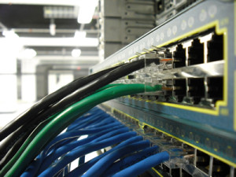

Modem
Modem is a device that enables a computer to send or receive data over telephone or cable lines. The data stored on the computer is digital whereas a telephone line or cable wire can transmit only analog data.
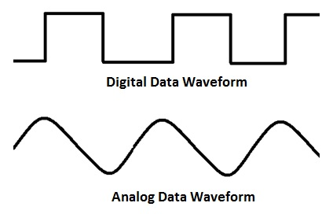
The main function of the modem is to convert digital signal into analog and vice versa. Modem is a combination of two devices − modulator and demodulator. The modulator converts digital data into analog data when the data is being sent by the computer. The demodulator converts analog data signals into digital data when it is being received by the computer.
Types of Modem
Modem can be categorized in several ways like direction in which it can transmit data, type of connection to the transmission line, transmission mode, etc.
Depending on direction of data transmission, modem can be of these types −
- Simplex − A simplex modem can transfer data in only one direction, from digital device to network (modulator) or network to digital device (demodulator).
- Half duplex − A half-duplex modem has the capacity to transfer data in both the directions but only one at a time.
- Full duplex − A full duplex modem can transmit data in both the directions simultaneously.
RJ45 Connector
RJ45 is the acronym for Registered Jack 45. RJ45 connector is an 8-pin jack used by devices to physically connect to Ethernet based local area networks (LANs). Ethernet is a technology that defines protocols for establishing a LAN. The cable used for Ethernet LANs are twisted pair ones and have RJ45 connector pins at both ends. These pins go into the corresponding socket on devices and connect the device to the network.
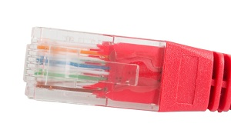
Ethernet Card
Ethernet card, also known as network interface card (NIC), is a hardware component used by computers to connect to Ethernet LAN and communicate with other devices on the LAN. The earliest Ethernet cards were external to the system and needed to be installed manually. In modern computer systems, it is an internal hardware component. The NIC has RJ45 socketwhere network cable is physically plugged in.

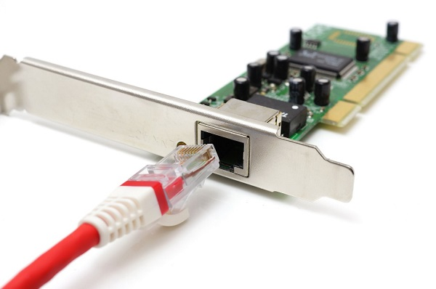
Ethernet card speeds may vary depending upon the protocols it supports. Old Ethernet cards had maximum speed of 10 Mbps. However, modern cards support fast Ethernets up to a speed of 100 Mbps. Some cards even have capacity of 1 Gbps.
Bridges
A bridge is a computer networking device that builds the connection with the other bridge networks which use the same protocol. It works at the Data Link layer of the OSI Model and connects the different networks together and develops communication between them. It connects two local-area networks; two physical LANs into larger logical LAN or two segments of the same LAN that use the same protocol.
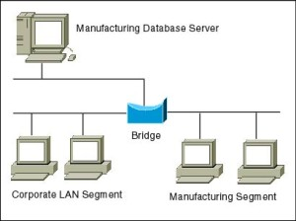
Apart from building up larger networks, bridges are also used to segment larger networks into smaller portions. The bridge does so by placing itself between the two portions of two physical networks and controlling the flow of the data between them. Bridges nominate to forward the data after inspecting into the MAC address of the devices connected to every segment. The forwarding of the data is dependent on the acknowledgement of the fact that the destination address resides on some other interface. It has the capacity to block the incoming flow of data as well.

Router
A router is a network layer hardware device that transmits data from one LAN to another if both networks support the same set of protocols. So a router is typically connected to at least two LANs and the internet service provider (ISP). It receives its data in the form of packets, which are data frames with their destination address added. Router also strengthens the signals before transmitting them.

Gateway
Gateway is a network device used to connect two or more dissimilar networks. In networking parlance, networks that use different protocols are dissimilar networks. A gateway usually is a computer with multiple NICsconnected to different networks. A gateway can also be configured completely using software. As networks connect to a different network through gateways, these gateways are usually hosts or end points of the network.
Gateway uses packet switching technique to transmit data from one network to another. In this way it is similar to a router, the only difference being router can transmit data only over networks that use same protocols.

Wireless Network
Wireless Networks can be divided into three main categories:
- System interconnection
- Wireless LANs
- Wireless WANs
System Interconnection
System interconnection is all about interconnecting the components of a computer using short-range radio. Some companies got together to design a short-range wireless network called Bluetooth to connect various components such as monitor, keyboard, mouse and printer, to the main unit, without wires. Bluetooth also allows digital cameras, headsets, scanners and other devices to connect to a computer by merely being brought within range.
In simplest form, system interconnection networks use the master-slave concept. The system unit is normally the master, talking to the mouse, keyboard, etc. as slaves.
Wireless LANs
These are the systems in which every computer has a radio modem and antenna with which it can communicate with other systems. Wireless LANs are becoming increasingly common in small offices and homes, where installing Ethernet is considered too much trouble. There is a standard for wireless LANs called IEEE 802.11, which most systems implement and which is becoming very widespread.
Wireless WANs
The radio network used for cellular telephones is an example of a low-bandwidth wireless WAN. This system has already gone through three generations.
- The first generation was analog and for voice only.
- The second generation was digital and for voice only.
- The third generation is digital and is for both voice and data.
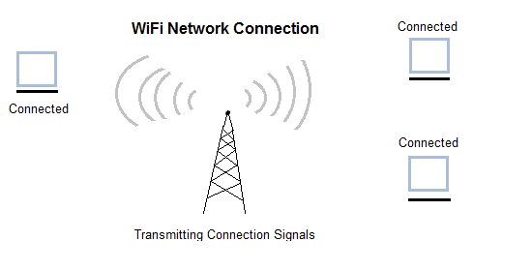

Inter Network
Inter Network or Internet is a combination of two or more networks. Inter network can be formed by joining two or more individual networks by means of various devices such as routers, gateways and bridges.

